<https://www.commonobjective.co/article/can-fashion-stop-climate-change>

Fashion: is it a dirty word? Although it doesn’t have the reputation of, say, the oil industry, it is making a sizeable contribution to warming the planet – the fashion industry was responsible for 1.7 billion tonnes of carbon dioxide in 2015, according to the [**Pulse of the Fashion Industry Report**](https://www.commonobjective.co/article/pulse-of-the-fashion-industry-2017) (to put things in perspective, that’s only slightly less than Russia).

The fashion industry produced almost 5% of manmade CO2 emissions in 2015 – more than aviation and shipping combined.  [Update: 8% according to [**research published in 2018.**](https://quantis-intl.com/wp-content/uploads/2018/03/measuringfashion_globalimpactstudy_full-report_quantis_cwf_2018a.pdf)]

# **Four ways fashion brands can reduce the negative effects of fashion**

## 1. Replace: switch raw materials

With raw materials making up the majority of a garment’s climate impact, efforts to reduce it are naturally focussed here. [**Switching fabrics**](https://www.commonobjective.co/search/resources?q=%22fabric+switch%22) can help. A switch from virgin polyester to recycled material – made by mechanically or chemically breaking down plastic drinks bottles – can reduce the carbon footprint of polyester by 40%.

**[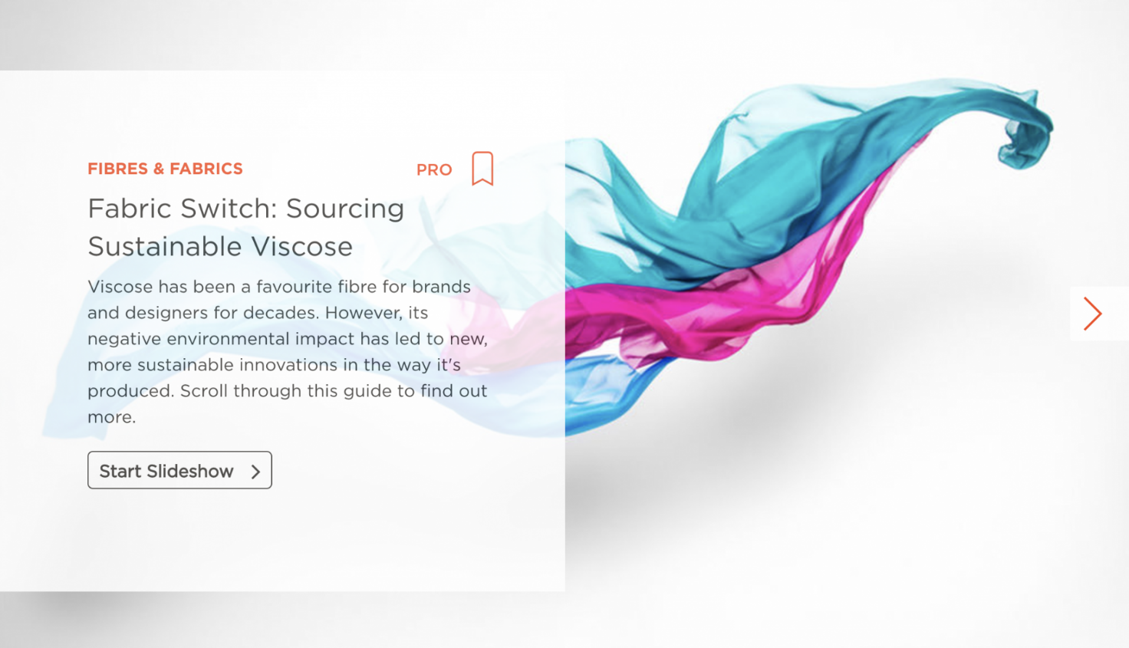](https://www.commonobjective.co/search/resources?q=%22fabric+switch%22)**[**Read CO's practical guides on how to switch fabrics**](https://www.commonobjective.co/search/resources?q=%22fabric+switch%22)

Outdoor apparel brand Patagonia have long been known for their use of recycled polyester, but other big players are getting on the act – Nike, H&M and Target are all among the top 10 users of sustainable synthetics.

Likewise, switching from conventional to organic cotton can cut harmful emissions by 46%, as the nitrogen waste from fertilisers is eliminated. Current supplies aren’t nearly enough to meet fabric demand – less than one per cent of all cotton production is organic – but the use of more sustainable fabrics will undoubtedly play a big role in reducing the climate impact of fashion in the future.

This may rely on new technologies that are only in their infancy now, such as [**man-made fibres made from agricultural waste**](https://www.commonobjective.co/article/agraloop-turning-food-waste-into-textiles).

## 2. Reduce: make energy savings along the value chain

Beyond the materials stage, firms can reduce energy use in their warehouses, stores and offices.

**[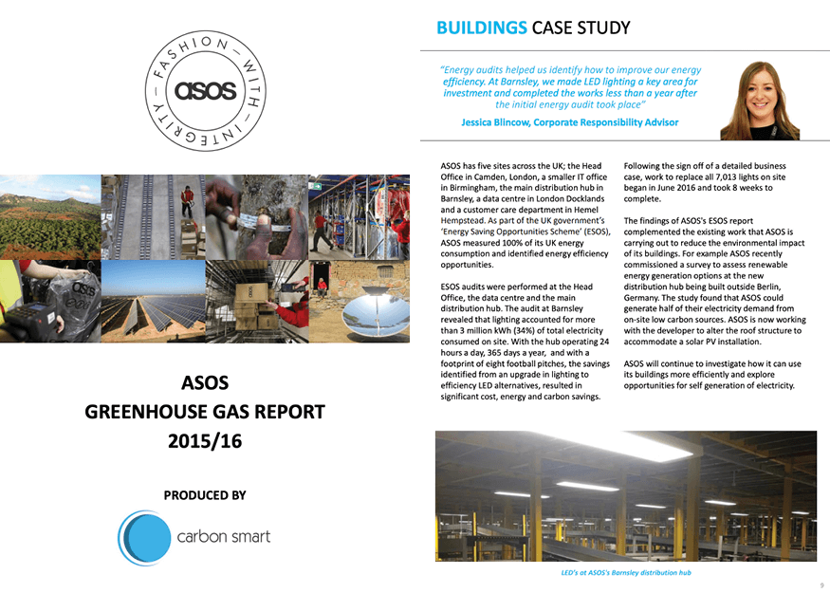](https://www.asosplc.com/~/media/Files/A/Asos-V2/documents/corporate-responsiblity/reporting-and-policies/public-ghg-report-2015-16.pdf)**Read ASOS' Greenhouse Gas Report 2015/16

ASOS cut its electricity use in one warehouse by 76% by switching to energy-efficient lightbulbs. Sensors that turn lights off in empty rooms can help too.

Finding efficiencies at  the transport and logistics stages can help businesses help the environment. When Hugo Boss analysed the carbon footprint of their transport operations, they realised switching from air to rail freight could cut emissions by 95%.

Improvements like these are all possible with existing technology, and can pay for themselves over a short timeframe.

## 3. Recycle: invest in systems to re-use rather than throw away clothes

Brands have a role to play in educating consumers about repairing and recycling their clothes. Some already operate repair services – Nudie Jeans patched up more than 44,000 pairs of jeans in 2016.

In 2014, Tonlé kept 70 tonnes of CO2 from entering the atmosphere by processing pre-consumer waste.

Several brands have in-store collection points for garments at the end of their life, which can be recycled, or resold for charity.

Wastage during the production stage needs to be taken seriously too – in 2014, Cambodian fashion brand Tonlé kept 70 tonnes of CO2 from entering the atmosphere by processing pre-consumer waste. In the future, automated processes such as optical fibre sorting may make recycling our clothes easier – we can’t go on throwing millions of tonnes of clothing into landfill every year.

## 4. Rethink: change the disposable fast fashion culture

Ultimately, for the fashion industry to make a positive impact on the climate, the culture of fashion needs to change. As Common Objective CEO Tamsin Lejeune points out, [**fast fashion is fundamentally unsustainable for the environment**](https://www.commonobjective.co/article/fast-fashion-can-it-be-sustainable).

The necessary reductions in greenhouse gas emissions won’t be possible unless we buy a lot less, and get much better at handling the end-of-life stage of garments. We must stop thinking of clothes as disposable, and adopt circular fashion principles that treat the life-cycle of a garment as a closed loop.

Creating an ecosystem that promotes and invests in new ways of thinking has to be part of the industry’s toolkit for tackling climate change. Perhaps, by 2050, fashion will have addressed the biggest waste of all – the vast majority of our clothes sitting unworn at any one time.

The future of fashion may be a service that replaces ownership with fast on-demand rental of fashion from a limitless global pool of outfits.

It could make the planet a better place and fashion no longer a dirty word.